The Bright Stars Program

When are applications accepted?
- Applications are currently being accepted for the upcoming school year, 2022-2023.
- Applications are accepted all year long and a waiting list is maintained to fill vacancies as they occur.

If I can’t apply online, how can I get an application?
- Any ACPS elementary school
- Download the application from any of these sites:
  - ACPS website: Click here
  - Department of Social Services website: Click here
  - Head Start: Click here
- Email the program coordinator, Carol Fox, at cfox@albemarle.org to have an application emailed or sent by US Mail
- Call the program coordinator, Carol Fox, at 434-484-0940 to have an application emailed or sent by US Mail

When will my application be processed?
An application is considered complete and will be processed when all of the documents listed below are received:
- Application ~ Online (preferred) or paper
- Proof of income ~ Documentation of all sources of income for all contributing adults in the household as noted below:
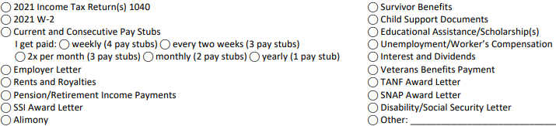

- Proof of address ~ One of the documents listed below:
Current deed, lease, or utility bill such as electric, cable, landline phone, or water
*Driver’s Licenses and W2 forms are not acceptable proof of residency documents
**If accepted, families must follow ACPS’ residency verification process when registering for school
- Family Eligibility Survey for those families applying online

If I can’t upload the documents when I applied online or I’m not applying online, how do I turn my documents in?
- Email documents to cfox@albemarle.org
*Email is not considered confidential unless the documents are password protected
- Fax documents to Carol Fox at 434-872-4518
- Bring documents to the Dept. of Social Services’ front office or place them in the locked dropbox at the 5th St. county office building ~ 1600 5th Street, Charlottesville
*This building includes the Department of Social Services, Housing, and Police, Fire and Rescue
- US Mail documents to Carol Fox, 1600 5th Street, Charlottesville, VA 22902
- Take pictures of the documents and text them to Carol Fox, at 434-484-0940

When will I hear about my application?
- Families will begin hearing about their application status the first week of May.
- Families who turn applications in after May 15th will be notified as soon as possible.

