GUIDEBOOK
for

TJSWCD & Camp Albemarle Meaningful Watershed Education Experience (MWEE)

for Albemarle County and City of Charlottesville Public Schools
TABLE OF CONTENTS:

Science Coordinator Responsibilities page 3
TJSWCD Coordinator Responsibilities page 3
Staff and Volunteer Responsibilities page 3
Map of Camp Albemarle page 5
Camp Albemarle Guidelines page 6
Information for school teachers page 6
Planning the daily schedule page 7
Inclement weather policy page 7
Example of daily rotation page 8
Watershed Educational Activities page 9
- Enviroscape Watershed Model page 10
- Soil Boxes Experiment page 12
- Macroinvertebrate Stream Station page 13
- Nature hike page 19
- Oh Deer! page 20
- Nature Bingo page 24
- Tree ID cards page 26
- Shad game page 28
- Scavenger hunt page 32
Science Coordinator Responsibilities:
Both Albemarle County and City of Charlottesville school districts have a science coordinator: Tony Borash for Albemarle County and Jessica Kalagher for Charlottesville. Their role is to schedule the Camp days with each of their schools and inform TJSWCD of the schedule. Jessica Kalagher will accompany all of her schools to Camp Albemarle and be a float person attending to the needs of the groups. There are 6 City fourth grade schools. Tony Borash will not be on site during Camp activities. He will put the TJSWCD coordinator in contact with the lead teacher at all participating schools. There are 16 Albemarle County fourth grade schools

TJSWCD Coordinator Responsibilities:

2 MONTHS IN ADVANCE –
- Touch base with Tony Borash and Jessica Kalagher to be sure they know who the coordinator is and have appropriate contact numbers.
- Check all schools are scheduled.
- Be sure that Don Tubbs (camp caretaker) has the dates scheduled as well.
- Line up staff & volunteers to work the dates wherever possible

1 MONTH IN ADVANCE:
- Check equipment to be sure it is all there and in working order: boots, nets, enviroscape, bug sheets, ice cube trays, magnifiers, etc.
- Contact teachers to be sure they have the Camp rules and guidelines, are getting ready for the trip, etc.

1 WEEK IN ADVANCE:
- Deliver soil boxes to the camp as well as any other needed equipment. (Can also be done the first day of camp.)
- Be sure the grass is growing well in the soil box.
- Be sure you have a schedule from the school of their activities, arrival and departure times, etc.

Staff & Volunteer Responsibilities:
Day of Camp Set Up:
- Dress appropriately for the weather, for safety (no open toed shoes), etc.
- Wear your name tag.
- Arrive half an hour or more before the scheduled bus arrival.
- Open bathroom doors and turn on the lights.
- If school is spending the night, check cabins for ‘varmints’. Chase them out.
- Carry table to the gravel bar at the stream station, carry boots tote with and sanitizer and towels to the lower section of the field by the stream station.
- Set up table for enviroscape beside the main building.
- Get water for the soil box experiment.
- Allow person doing the nature hike to walk the trail to check for hazards, what is growing or available to be seen, etc.
- Insofar as possible, use plastic containers, not glass, for the various stations.
- Mark a turn around place for the buses. Assign someone to make sure no one parks there.
- Greet parents and staff as they arrive.
- Greet the bus drivers and direct them to the turn around spot.
- Determine who will be in charge of ringing the bell to change stations. Be sure they have a schedule and a watch! (Enviroscape leader)
- NO BUS IS TO BE UNLOADED UNTIL ALL BUSSES ARE TURNED AROUND AND PARKED!
- Ask the lead teacher for a count of students and adults attending for TJSWCD records. Master Naturalists also need a demographic breakdown (sex, race) for their reports. If you can furnish that, it would be VERY helpful to them.

Day of Camp Break Down:
- Return stream station items and Enviroscape Model to the storage closet
- Make a note of anything missing or broken and let TJSWCD know
- Check bathrooms for damage, running plumbing and turn off the lights and close the doors.
- Also check cabins for open doors and/or lights.
- Be sure the lodge has all lights and fans off and is shut.
- Pick up any loose trash.
- Place large trash bags into dumpster.
- The caretaker will lock things up.
- Take all lost and found items to TJSWCD offices.
- If there have been any accidents on site request teacher to send an incident form to TJSWCD. Please also let TJSWCD know.

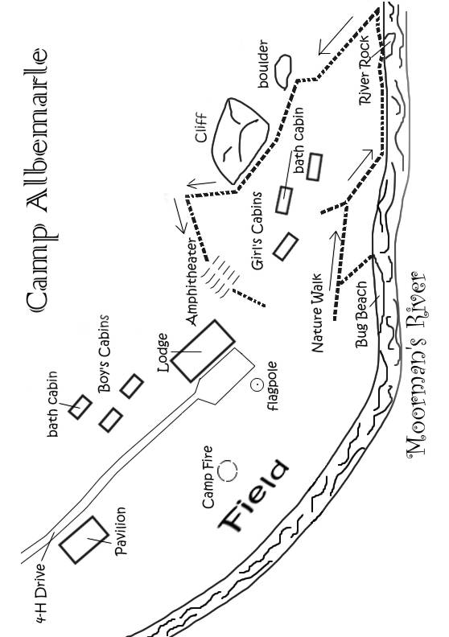
Camp Guidelines:
- Number one rule is RESPECT – respect your safety, safety of others, right to learn, the camp, the natural things.
- No climbing on rocks.
- What starts on the ground STAYS on the ground. . no throwing rocks, picking flowers, etc. All bugs are returned to the river.
- No horseplay in the stream, stay knee depth or less.
- No swimming in the stream.
- All students should stay with their group leader at all times.
- Students using the bathrooms should be in pairs.
- Please let staff know if you find any problems that pose a safety threat to your students (broken windows, loose railings, etc.) so that he can notify the camp.

School Teacher’s Information:
- Provide nametags for all students
- It is great if there is some way to differentiate the groups (e.g. color coded nametags, t-shirts, etc.).
- Fifteen pairs of boots are available for use by students during the in-stream macroinvertebrate sampling activity. Students who opt to not wear these are encouraged to bring an extra pair of sneakers to change into, shorts or trousers that can be rolled up, and their water shoes MUST have closed toes for protection in the river.
- Toilet paper and paper towels will be supplied by the camp.
- Bathroom facilities are provided for both students and adults. The bathrooms inside the lodge are for adults. Students are to use the outdoor bath houses - boys to the left of the main lodge, girls to the right.
- Camp Albemarle now has a caretaker who will open the camp by 8:30 a.m. and close up after you leave. Both the main gate and the lodge will be open when you arrive.
- There is a telephone in the main lodge for use in emergency, as cell reception is often poor at the Camp
- Schools are responsible for bringing first aid kits for the students. We encourage each “team” of students to have a first aid kit with the supervising adult.
- Schools are responsible for ensuring students have necessary prescription medicines with them for the day. Please let the education staff know if some of your students have special needs or conditions we need to be aware of.
- Schools are responsible for ensuring all students have lunch, including those receiving lunch from the school.

Planning Daily Schedule/Rotations:

Each school has a different number of students in attendance. Please know the total number of students, and break them into groups of twenty or less per “team.” Each “team” will rotate through the camp stations throughout the day.

Some common stations are (please use enclosed map):
-- Enviroscape at the lodge
-- Leaf ID/Nature Art in the pavilion
-- Oh Deer/Scavenger Hunt in the field
-- Stream bugs at the beach
-- Nature Hike from the field near the girls cabins
-- Lecture in the amphitheater

Most schools choose to rotate clockwise or counterclockwise around the Camp (please see enclosed map, page 5). A schedule of rotation is expected at TJSWCD at least a week prior to the camp day. Please see the example of a rotation schedule below. In this example the students are divided into four teams (Red, Blue, Yellow, Green), and they rotate through four stations counterclockwise. Please note they have two scheduled breaks for food, drinks, and bathroom. Also in between stations there is a five minute transition scheduled.

Inclement Weather Policy

It is up to the schools to cancel Camp Albemarle activities due to poor weather. The TJSWCD coordinator will watch the weather in the days leading up to the Camp and contact the schools or science coordinators with any possible poor weather of concern. The schools will cancel at the latest by 8.15 am on the day of their Camp. This will allow the TJSWCD coordinator time to call all staff and volunteers and inform them of the cancellation prior to them leaving home for the work day.
Example of Rotation Schedule from a school

 | 9:30-9:50 | 9:50-10:30 | 10:35-11:15 | 11:15-11:25 | 11:30-12:10 | 12:10-12:40 | 12:45-1:25 | 1:25-1:35 | 1:35
STATIONS |  | Group | Group |  | Group |  | Group |  | B
STREAM STUDY | A S | Red | Yellow |  | Blue |  | Green | p | U
 | R E |  |  | S |  | L |  | C A | S
NATURE WALK | R T | Green | Red | N | Yellow | U | Blue | L C
 | I |  |  | A |  | N |  | E K | B
ENVIROSCAPE | V U | Blue | Green | C | Red | C | Yellow | A | A
 | E P |  |  | K |  | H |  | N U | C
GEO-STATION |  | Yellow | Blue |  | Green |  | Red | P | K

Watershed Education Activities:

Normally the TJSWCD staff conducts three stations at Camp Albemarle: the stream sampling station, the nature hike, and the Enviroscape watershed model station. Schools are encouraged to plan additional activities to complete the number of stations that the group will require to fill their time at the Camp.

Included herein are instructions and materials for activities that have proven successful in the past:
1. Enviroscape
2. Soil Boxes
3. Macroinvertebrate Stream Monitoring
4. Nature Hike 5. Oh Deer!
6. Nature Walk Bingo
7. Tree I.D.
8. Shad game
9. Scavenger Hunt
10. Geologic perspectives (pending from Marilyn)

Enviroscape: Procedure

The Enviroscape is a model of a watershed used to explain what a watershed is, discuss the water cycle, and demonstrate how land use within a watershed can cause various types of water pollution.

I. Definition of watershed: an area of land on which all runoff from the rain that falls will
drain to the same place (at the bottom of the watershed).
-Using the Rivanna Map ask students what watershed they live in, work on the James Basin too, and mention how they all go to the Chesapeake Bay
-Ask students where runoff goes when it falls on the roof of the lodge or on the hillside across the river (downhill to the Moorman River)
-Watersheds can be small or large
1. Moorman River Watershed
2. Rivanna River Watershed
3. James River Watershed
4. Chesapeake Bay Watershed
-Can discuss the importance of having clean water in the Moorman River to people in
Charlottesville who get their water from the Rivanna Reservoir.

II. Students Identify Land Use on the Model
- Ask students where runoff goes when it falls on top of the hill in the model (downhill
to the body of water at the bottom).
- Identify land use on the model
A. farm
1. plowed field for crops (ask students for examples of crops)
2. livestock (identify animals and food products they produce)
B. roads
C. houses
D. construction
E. forestry/lumbering (identify products derived from trees)
F. golf course (hint: game played on grass with sand traps)
G. factory (identify some products produced in factories)
H. waste water treatment plant (treats waste water from houses before returning it to river)

III. Students identify pollution produced by each land use (with brief discussion of effects of pollution)
A. soil/erosion (What do you call it when rain washes the soil away?)
1. plowed field
2. livestock (if overcrowded)
3. construction (if no erosion controls)
4. forestry (if no replanting or erosion controls)
5. stream banks (if no plants to protect banks)

B. nutrients/fertilizer/animal waste
1. plowed field (fertilizer for crops)
2. pasture/livestock (animal waste)
3. houses (lawns and gardens/failing septic system)
4. golf course (fertilizer for grass)
5. waste water treatment plant (overflows in heavy rain)
C. oil and gas
1. roads
2. parking lot
D. other
1. factory

IV. Watershed Review
A. Ask students to define a watershed again.
B. Ask students where all the runoff in the model ended up.
C. Ask students where all the pollution ended up
1. Point out that pollution on the roof of the lodge or on the field below ends up in the
Moorman River.
2. Ask where else the pollution goes (Rivanna, James, Chesapeake).
3. Point out that people in the same watershed are connected; that pollution always ends
up downstream, which can be as far away as the Chesapeake Bay.

V. How to prevent water pollution
A. Farm
1. Use as little fertilizer as needed (according to soil test)
2. Fence cows out of creek
3. Establish filter strips and/or buffers along waterways
B. Roads/vehicles
1. Keep vehicle in good repair
2. Never pour used motor oil down drain, in woods or in driveway (recycle at
garage)
C. Houses
1. Use as little fertilizer on lawns and gardens as needed (according to soil test;
follow instructions on fertilizer bag)
2. Inspect and pump septic tank as needed
D. Construction
1. Silt fences
2. Sediment trap/basin
E. Forestry
1. Replant trees
2. Use silt fences and sediment traps as needed
F. Golf Course
1. Use as little fertilizer as needed (according to soil test)

Soil Boxes: Procedure

Three soil boxes may be used to supplement the Enviroscape lesson with a soil erosion experiment which demonstrates the role that plants and mulch cover play in protecting soil from erosion, and illustrates the fact that grass and other plants keep stormwater runoff cleaner than either mulch or bare soil because roots help hold the soil in place.

I. Discuss the importance of soil
A. Point out that almost everything we eat depends on the soil; challenge students to
name anything we eat that does not depend on the soil
1. fruits and vegetables
2. meat (animals eat plants or other animals that eat plants)
II. Conduct the erosion experiment
A. Ask what it is called when rain washed away the soil.
B. Ask what is in the first box (soil)
1. point out that all three boxes contain the same amount of soil
2. ask what is on top of the soil in the second box (straw/hay)
3. ask what is growing in the soil in the third box (grass)
C. Tell the students that they will make it "rain" on each of the boxes using a
sprinkling can and use a jar to catch the water that comes out the front.

1. Ask students what it is called when a scientist makes a scientific guess (hypothesis)
2. Ask what they think the water that comes out of the first box (bare soil) will look like (erosion will carry soil out with the water)
3. Ask whether they think the water coming out of the second box (straw) will have more or less soil in it than the water coming out of the first box
4. Ask whether they think the water coming out of the third box will contain more or less soil than water coming out of the second box
D. Choose volunteers to use the watering can in the back of the truck and to catch the water coming out of each box.
E. Have the volunteers hold up the jars and compare.
1. Discuss whether the hypotheses were confirmed or disproved .
2. Discuss how mulch and grass (and other plants) protect soil from erosion.
Benthic Macro-invertebrate Stream Sampling

Macroinvertebrate stream sampling is a technique used to monitor the health and water quality of streams. The technique depends on the fact that the insect larvae and other macroinvertebrates that live under rocks on the bottom (benthos) of streams can be divided into three groups depending on their sensitivity to pollution in the water:

Group #1: Sensitive to pollution (cannot survive in polluted water).
Group #2: Somewhat sensitive to pollution (can survive at low levels of pollution).
Group #3: Tolerant of pollution (can survive, or even thrive, in polluted water).

A stream is deemed healthy if the majority of species captured are sensitive or somewhat sensitive to pollution. Diversity (a number of different species) is also an indicator of a healthy stream with good water quality. The stream probably has pollution problems if only pollution-tolerant species are found. The procedure used at Camp Albemarle has been adapted from the Virginia Save Our Streams protocol for use with elementary and middle school students.

Procedure
1. Ask students the name of the river (Moorman). Ask why it is important to people living
in Charlottesville (it flows into the Rivanna River Reservoir from which Charlottesville gets
all its drinking water, etc). Have the students
2. Ask the students to observe the river from the bank and give their opinion on whether the water looks dirty or clean. Fill a glass jar with a sample of the water and hold it up. Remind students that while the water looks clean, some kinds of pollution cannot be seen. That is why we will be catching the insect larvae that live under rocks in the stream to reach a conclusion regarding the water quality.
3. Students capture a sample of benthic macroinvertebrates in the Moorman River using a net (kick seine). Two students hold the net in place while others stir up the bottom to dislodge the insect larvae. The sample is then examined on shore. Macroinvertebrates are removed from the net, placed in ice cube trays and identified with the help of the instructors. Green (sensitive), Yellow (somewhat sensitive) and Red (tolerant) cards are available to help in identifying the macroinvertebrates and determine their sensitivity to pollution.
4. A good wrap-up activity is to share the specimens collected by each group with the other groups, asking students to identify them and determine whether they are sensitive, somewhat sensitive or tolerant of pollution. Based on the results, ask the students whether they think the water in the Moorman River is relatively clean or polluted.
Field Worksheet: Calculating an Index of Water Quality

Use the Macroinvertebrate Invertebrate Species cards to identify each organism you collect. Write the name of each kind of macroinvertebrate on a line under the class it belongs to - Class 1, Class 2 or Class 3 - using the lists below. Perform the calculations and add up the numbers to get your Water Quality Index.

Class 1 – Pollution Sensitive

caddisfly larva stonefly larva
mayfly larva gilled snail

Class 2 – Moderately Pollution Tolerant

"water penny" hellgrammite fingernail or pea clam
riffle beetle dragonfly larva crayfish
netspinner damselfly larva

Class 3 – Pollution Tolerant Organisms

blackfly larva cranefly larva lunged snail
midge larva aquatic worm leech
horsefly larva

Water Quality Index
Excellent = 23 and above
Good = 17 – 22
Fair = 11-16
Poor = 10 or below
Biological Monitoring Field Worksheet

River: Temperature:

Weather: Water Level:

Class 1 (Sensitive to Pollution – they need clean water!)

Total number of TYPES found: X 3 =

Class 2 (Somewhat Sensitive to Pollution.)

Total number of TYPES found: X 2 =

Class 3 (Tolerant of Pollution)

Total number of TYPES found: X 1 =

GRAND TOTAL =
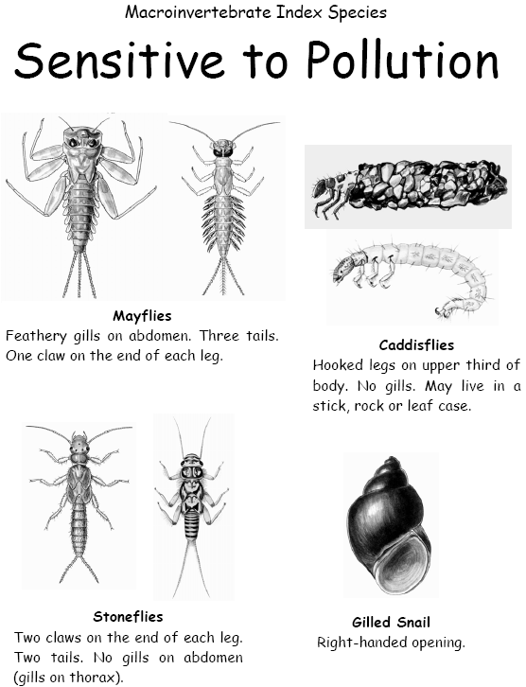
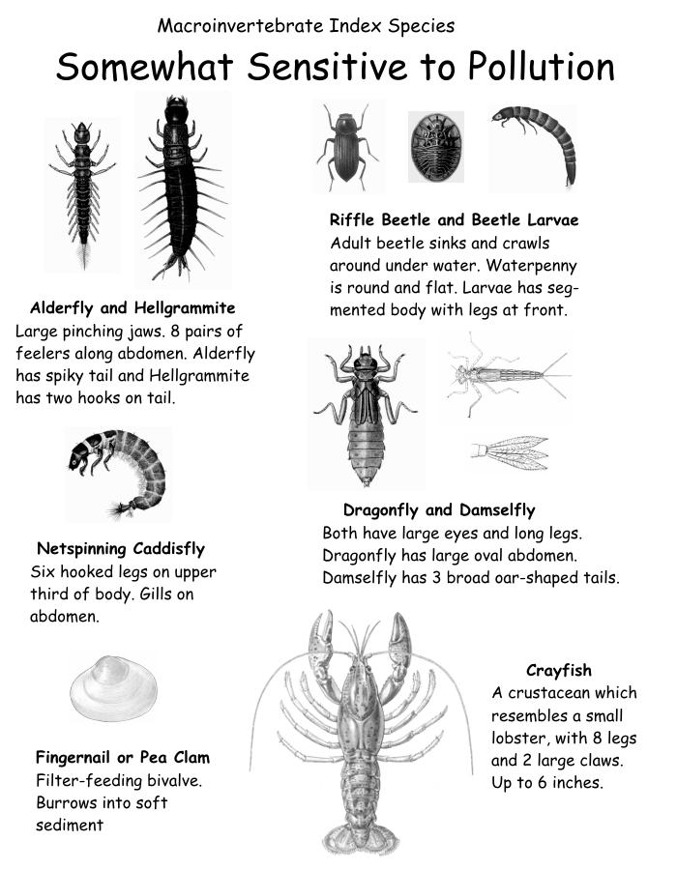
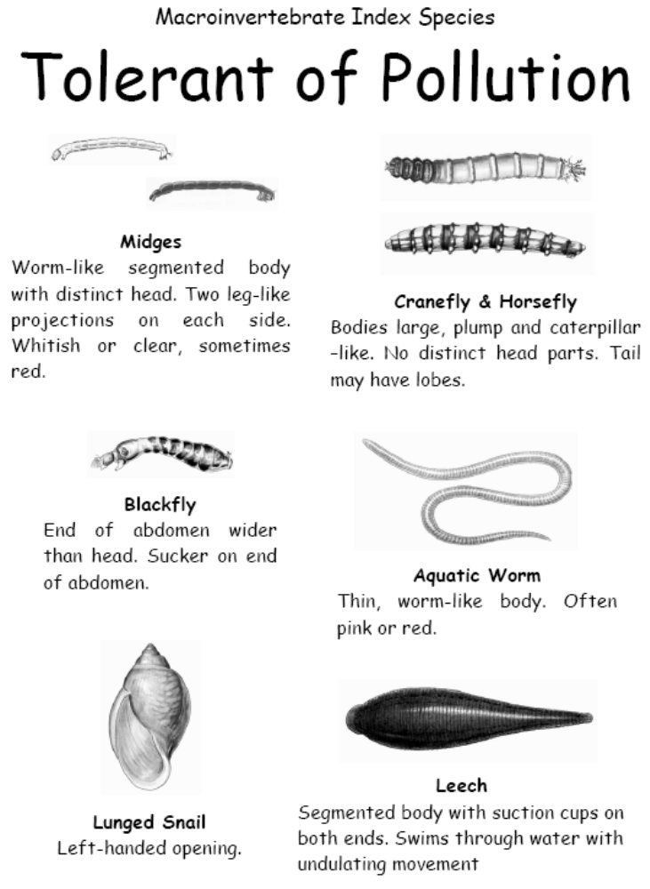

Nature Hike
The Nature Hike has no prescribed format. You should walk the trail before the students arrive to know what is available for discussion that day. If you need a more rigid program use the Nature Bingo idea below.

Begin in the field to the right (towards girls bathrooms) of the lodge. Gather all the students and ensure there are adults at the back of the group also. The walk follows the Camp Albemarle trail either counter clockwise to the river, and up the hill to the rock outcrop, ending at the amphitheater; or clockwise starting at the amphitheater and coming downhill to the river and field. The amphitheater makes a good venue for sitting at the end or the start to discuss what you can see, look at trees, leaves, rocks. The rock outcrop is a good gathering point to discuss things. Make sure you include all of the group in the discussions, take your time, ask the adults at the back to please keep up and not talk too much about unrelated topics.

Explain that the nature hike is an exploration of everything and anything they can see, smell, touch, feel, and hear.

Some features of note on the trail are as follows:
- Lichens on the rock outcrops
- Beaver damages to trees along the trail
- Big trees and small mosses, all plants but so very different
- Can discuss the layers of the forest canopy – ground cover, shrubs, understory, canopy
- Smell the wild ginger and sassafras
- Everygreen laurels versus deciduous trees
- Leaf shapes and textures – you could collect leaves for leaf rubbings
- Bark textures – you could do bark rubbings
- The rocks inclined at an angle, why?
- Any birds you see or hear
- Insects on the trail
- Details in the rocks – crystals, layers, colors
- The decay of wood, some really soft and squishy, newer stuff is hard, why?

Oh Deer A game of animal populations
(adapted from Project Wild K-12 Curriculum and Activity Guide)
http://www.riverventure.org/charleston/resources/pdf/population%20study%20game.pdf

Objectives - Students will be able to:
1. Identify food, water and shelter as three essential components of habitat.
2. Describe factors that influence carrying capacity (how large a population a habitat can support)
3. Define limiting factors and give examples
4. Recognize that some fluctuations in populations are natural, while others result from human impact

Method
Students portray deer and habitat components in a physical activity.

Materials
- an outdoor area large enough for students to run (ideal: playing field)
- cones to mark boundaries,
- paper and writing utensil (for teacher or adult chaperone to record data)
- optional: habitat component cards

Background
Students often think of a healthy ecosystem as “balanced”, not realizing that every relationship and population is dynamic and changing over time as a result of many different environmental or cultural variables. Wildlife populations are not static; they fluctuate in response to a variety of stimulating and limiting factors.

Carrying capacity is the dynamic balance between the availability of resources and the population a habitat can support. Many factors related to carrying capacity determine the ability of a species to survive and to successfully maintain a strong population. All animals are dependent upon habitat, and the four basic components of habitat are food, water, shelter and space in a suitable arrangement. This activity emphasizes three of those habitat components – food, water and shelter – but the students should not forget the importance of the animals having sufficient space in which to live, and that all the components must be in a suitable arrangement for wildlife populations to reach their maximum size.

In nature, populations are prevented from reproducing to form a larger population than the habitat can support by limiting factors. Disease, predators, weather conditions and habitat destruction and degradation all limit the size of a population.

Procedure

Ask the students to define habitat. Ask if humans have a habitat. How about domestic animals? Ask if humans share habitat with wildlife.

Review the four essential components of habitat: food, water, shelter and space in a suitable arrangement. Tell the students they will be focusing on three of the habitat needs of deer in this activity. The essential components for survival of deer are food, water and shelter and space in a suitable arrangement, but in this activity we will assume the deer have enough space.

Ask the students to count off in fours. Have all the ones go to one area; all twos, threes, and fours go together to another area. Mark two parallel lines on the ground ten to twenty yards apart. Have the ones line up behind one line; the rest of the students line up behind the other line facing the ones.

The ones become deer. All deer need good habitat to survive. Again, ask the students what the essential components of habitat are for a deer (food, water, forest for shelter, and fields for browsing). The deer need to find food, water, shelter, and space in a suitable arrangement to survive. In this activity we will assume the deer have enough space in which to live.
- When a deer is looking for food, the student should place his "hooves" over his stomach.
- When a deer is looking for water, the student places his hooves over its mouth.
- When a deer is looking for shelter, the student should put his hands together over his head, making an arch.
A deer can choose to look for one of these needs during each round of the game; the deer cannot, however, change what it is looking for (e.g. when it sees what is available during that round). It can change what it is looking for in the next round if it survives.

The twos, threes and fours are all components of habitat: food, water and shelter. Each student is allowed to choose at the beginning of each round which component he will be during that round. The students depict which component they are in the same way the deer show what they are looking for (i.e. hands on stomach for food, and so on).

The activity starts with all the players lined up behind their respective lines (deer on one side, habitat components on the other side) and with their backs facing the students along the other line.

Begin the first round by asking all of the students to make their signs - each deer deciding what it is looking for, each habitat component deciding what it is. Give the students a few moments to put their hands in place-over stomachs, over their mouths, or over their heads.
NOTE: Switching symbols in the middle of a round can be avoided by having the students put on habitat component cards that show an illustration of what they are looking for, or what they represent. At the start of each round, students choose one of the cards.

When the students are ready, say, “Oh, Deer!” Each deer and each habitat component turn to face the opposite group, continuing to hold their signs clearly.

When the deer see the habitat component they need, they should run to it. Each deer must hold the sign of what it is looking for until getting to the habitat component with the same sign. Each deer that reaches its necessary habitat component takes the “food”, “water”, or “shelter" back to the deer side of the line. “Capturing” a component represents the deer successfully meeting its needs and successfully reproducing as a result. Any deer that fails to find food, water, shelter dies and becomes part of the habitat. That is, any deer that died will be a habitat component the next round and so is available as food, water, shelter to the deer that are still alive.
NOTE: When more than one deer reaches a habitat component, the student who arrives first survives. Habitat components stay in place until a deer chooses them. If no deer needs a particular habitat component during a round, the habitat component just stays where it is in the habitat. The habitat component can, however, change which component it is from round to round.

Record the number of deer at the beginning of the game and at the end of each round. Continue the activity for approximately 15 rounds.

At the end of 15 rounds, bring the students together to discuss the activity. Encourage them to talk about what they experienced and saw. Discuss what role limiting factors played (when there was less of one habitat component available). Discuss how a larger population further depletes the habitat, and then a "die-off" occurs, reducing the population and bringing the two back into balance. You can introduce natural selection by pointing out how the fastest (or smartest) deer got to limited resources before the others.

Follow-up Classroom Activity:
- Back in the classroom, use an overhead projector, flip chart, or chalkboard to post the data recorded during the activity. The number of deer at the beginning of the activity and at the end of each round represents the deer in a series of years. The students will see from this graph that a population is dynamic. The process is natural as long as the factors that limit the population do not become excessive to the point where the animals cannot successfully reproduce. The wildlife populations will tend to peak, decline, and rebuild; peak, decline, and rebuild-as long as there is good habitat and sufficient numbers of animals to reproduce successfully.
- Ask the students what is realistic and unrealistic about this simulation? (Deer that do not survive do become recycled as nutrients but it is not instantaneous. Deer need all habitat components to survive. Poor habitat usually results in a weakened individual that succumbs to disease, not instant death).
- In discussion, ask the students to summarize some of the things they learned from this activity. What do animals need to survive? How do these components influence carrying capacity? What are some “limiting factors” that affect the survival of animals? How do factors that limit carrying capacity affect the health, numbers, and distribution of animals? How do these factors affect competition within a species? Why is good habitat important for animals? Are wildlife populations static, or do they tend to fluctuate as a part of an overall “balance” of nature? Is nature ever in “balance” or are ecological systems involved in a process of constant change?

Variations
- After the students have played several rounds of “Oh, Deer”, introduce a predator, such as a human hunter, mountain lion or wolf. The predator starts in a designated “predator den” area off to the side. The predator has to skip or hop. This impediment reduces the possibility of violent collisions between deer and predator. The predator can tag deer only when they are going toward the habitat and are tagged between the habitat and the deer lines. Once a deer is tagged, the predator escorts the deer back to the predator den. The time it takes for the deer to be taken back to the den simulates the time it takes to be “eaten”. The “eaten” deer is now a predator. Predators that fail to tag someone die and turn into habitat. That is, in the next round the predators that died join the habitat line. They will become food, oxygen, or shelter. During each round, keep track of the number of predators as well as the number of deer. Incorporate those data in the graphs.
- After the students have played several rounds of “Oh, Deer”, create different environmental scenarios which will alter the habitat available to the deer. Huddle the habitat components and tell them the situation and the limiting factor. Be certain the deer cannot hear you. Run through the constructed round with the limiting factor and then tell the deer the scenario. Have the students discuss these events and how they alter the graph.

Proposed Scenarios:
- A severe drought occurs and oak trees produce few acorns in the fall.
Limiting Factor: Food. No habitat components choose to represent food.
- Humans build a subdivision, replacing farm fields and forest with houses and lawns.
Limiting Factor: Shelter. No habitat components choose to represent shelter.
- A factory is built which discharges toxic waste into a stream.
Limiting Factor: Water. No habitat components choose to represent water.
4. A forest fire occurs, burning all vegetation.
Limiting Factors: Shelter and food. No habitat components choose to represent shelter and food.
Nature Walk Bingo Cards
Objectives:
- Encourage students to observe everything around them on the nature trail using their
sense of sight, hearing, touch and smell.
- Familiarize students with a few of the more common sights in the Virginia forest.

Materials:
One copy of the Nature Walk Bingo Card for the facilitator (or two can be used, if there is one
adult at the front and one at the back of the group of students).

Markers/Pencils

Preparation:
Have 1 or 2 copies of the Nature Walk Bingo Card available for each group of students. The
cards can be laminated and used more than once with wet erase overhead markers.

Procedure:
Tell the students they will be taking a short walk on the Camp Albemarle nature trail. They will
be asked to observe everything around them using their eyes, their ears and their senses of touch
and smell.

Whenever someone finds something on the card, they are encouraged to share it with the group,
and will be given the card to mark off the item. Finding (or failing to find) items on the cards can
be an opportunity for discussion with the group about various environmental topics.

Alternate Procedure:
Have copies of the Bingo Cards for each pair of students to mark.
Draw up and copy any variation of the cards you want to discuss, can include geology, bird
sounds, soils, shapes.

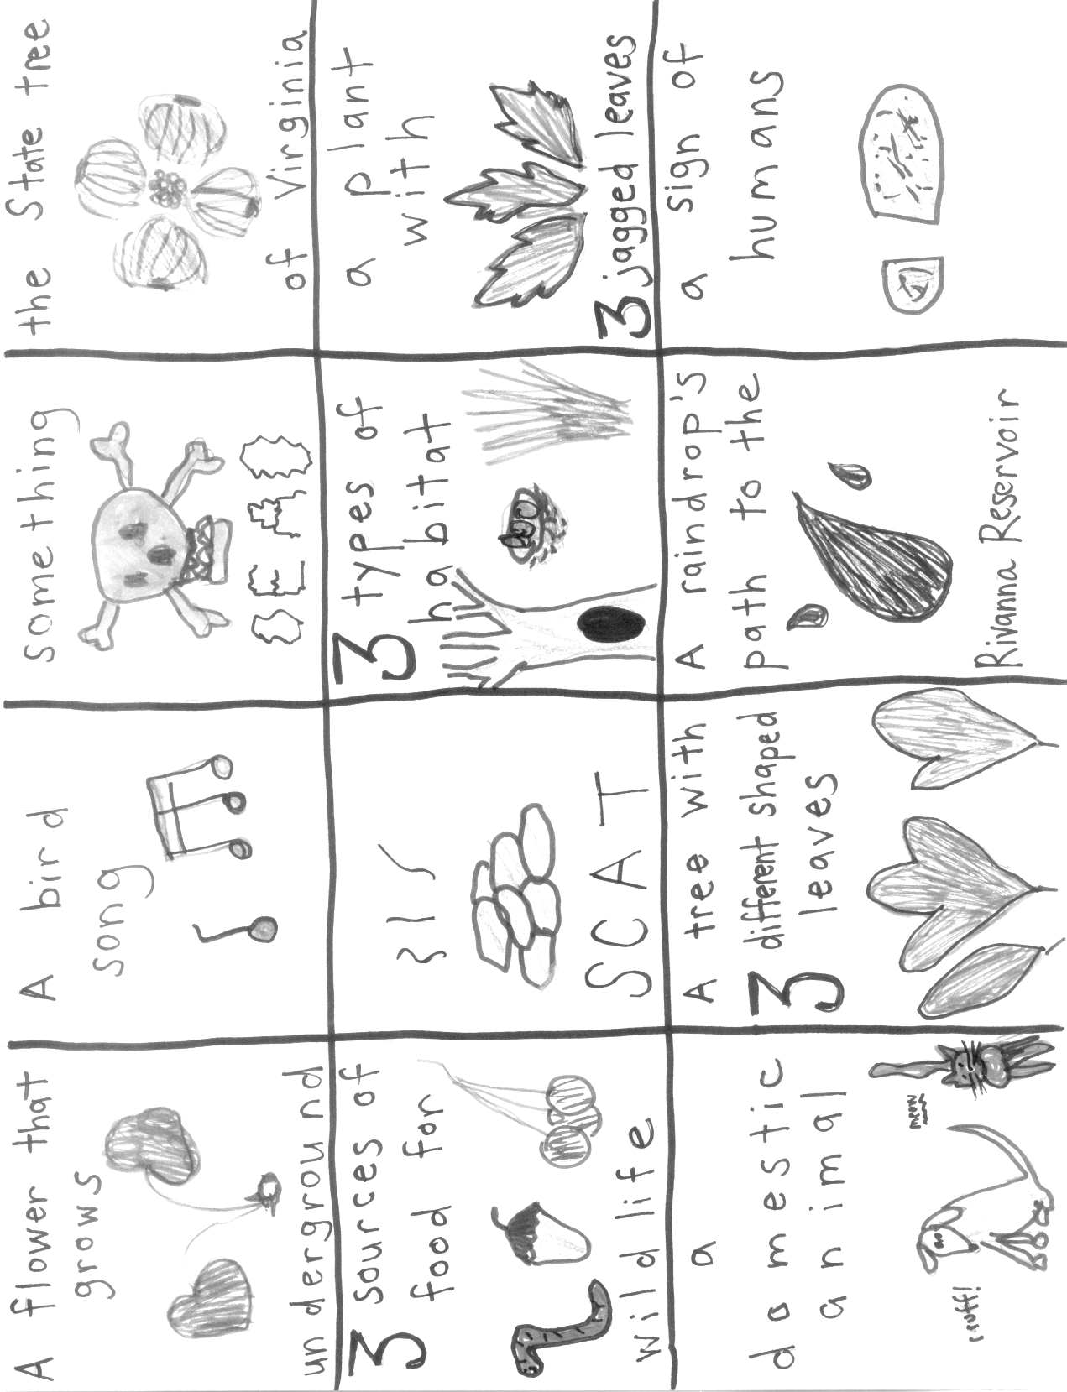

Tree I.D.: This book (Forest Trees of Virginia) is available at TJSWCD offices. Tree ID can be done in the pavilion at Camp Albemarle, with a good selection of trees nearby.
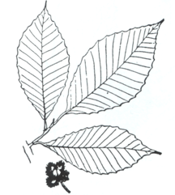  Beech | 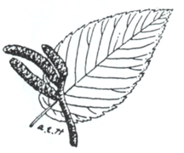  Black Birch
Leaves 3 to 4 inches long, pointed at the tip and coarsely toothed along the edge. Bark is distinctly smooth. | Leaves alternate, 3 to 4 inches long. Break a twig for the distinctive smell of "root beer".
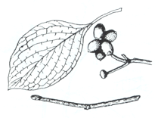  Dogwood | 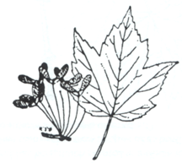  Red Maple
Leaves opposite, 3 to 5 inches long, wavy along the edge. Bark broken up into small 4-sided blocks. | Leaves 2-5 iches long with 3 saw-toothed lobes. Seeds are winged and fall in a spiral motion.
Tree I.D (continued)

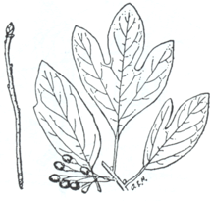  Sassafras | 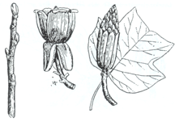  Tulip Poplar (or Yellow Poplar)
Leaves can have 1, 2 or 3 lobes of the shapes shown above, 4 to 6 inches long | Leaves are 4 to 6 inches long, with 4 lobes. Tulip-shapes flowers appear in April.
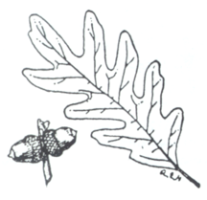  White Oak | 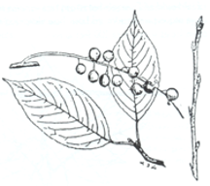  Wild Cherry (or Black Cherry)
Leaves alternate and 5 to 9 inches long, deeply divided into 5 to 9 rounded finger-like lobes. | Leaves are alternate and pointed with edges broken by many fine, incurved teeth. Bark has a bitter-almond taste.

Shad Game……or Hooks and Ladders
This game designed originally to teach about salmon can be used for shad which are being restored in our area. (Source: http://sns.ucdavis.edu/index.php/activity_2_the_incredible)

Overview
In this activity, participants act out the shad journey from spawning ground, to the open ocean, and then back to spawning ground. In doing so, they begin to understand the unique characteristics of shad.
Background Information
This activity introduces participants to the interesting life cycle of shad by acting out a simplified version of it. Migratory fish face many challenges throughout their life cycle, including silt smothering the eggs, predators, pollution, disease, oxygen-poor water, high water temperatures, lack of food, and barriers such as dams and culverts. Only one or two from an egg nest (1/10 of 1%) make it back to their home streams to spawn.
Objectives
Participants will: (1) simulate the shad’s journey from spawning ground to the ocean and back, and (2) identify obstacles these fish face at different parts of the journey.
Materials
- Large playing area (at least 50 feet x 100 feet)
- One long jump rope and two short ones
- Existing painted lines, rope, traffic cones or other boundary markers
- Two cardboard boxes
- 100 tokens (try to use biodegradable token – cardboard disk for example)
- Whistle (optional)
Advance Preparation
  - Set up the boundaries for the game as shown in the illustration below
  - About one-fourth of the playing area will be for the downstream journey to the ocean. It will include a dam turbine (long jump rope) and predators.
  - Half of the playing area will be for the open ocean, and will have two fishing boats (boxes) with fishers.
  - The remaining one-fourth of the playing area will be for the upstream journey back to the spawning ground. Here fish will pass through a fish ladder (crouching participants) and jump over a waterfall (broad jump).
- The procedures for this activity assume a group size of about 30 participants. As you plan for the activity, add or subtract one predator and one fishing boat to adjust for a larger or smaller group.
- Place the materials for the activity as shown:
  - Put the long jump rope in the turbine area.
  - Place the two cardboard boxes in the open ocean area.
  - Scatter half the tokens on each side of the open ocean, just outside the boundary. Use biodegradable tokens please.
  - Position the two short jump ropes at the waterfall area. They should be far enough apart to provide a challenging, but realistic, broad jump.
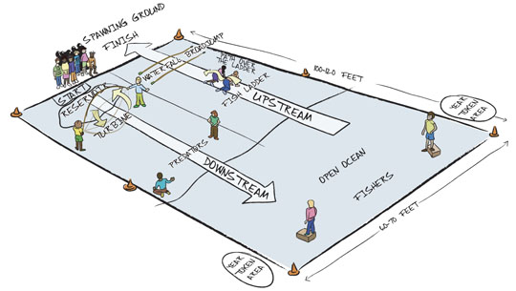
Lifecycle Game Setup
Setting the Stage
- Begin by asking participants, “Why have people celebrated shad throughout the ages and why do they continue to celebrate shad? What makes these fish so special?”
- Ask them, “What does the word ‘migration’ mean?” What are some reasons that people migrate? Why might shad migrate?”
- Tell participants that to help them understand these questions, they will be acting out the amazing journey of the shad migration from the spawning ground to the ocean and back again, and including some of the obstacles that shad face along the way.
Conducting the Activity
- Take participants to the playing area and explain that most of them will act as shadfor the activity. Describe the journey that these “shad” must take:
  - Spawning Ground: All the shad start in the spawning ground. When you blow a whistle (or give other signal), they will start their journey downstream.
  - Dam Turbine: After they begin their journey, the shad face their first hazard - a dam turbine represented by two participants swinging the long jump rope. All shad must go through the turbine. If a shad is hit by the jump rope or a turbine operator’s arm, it dies. Dead shad become part of the fish ladder (see Fish Ladder). The turbine operators may change the speed of the turbine to try to catch shad.
  - Predators: Once they pass the turbines, the shad must face two wildlife predators (who may be larger fish, birds, or mammals). These predators must use both hands to catch the shad. Upon catching a shad, the predator must escort the dead shad over to the fish ladder area (see Fish Ladder) before returning to catch more.
  - Open Ocean: All shad that make it past the predators reach the open ocean. Here, shad can be caught by fishers in fishing boats (boxes). The fishers must keep one foot in their box, but can slide the box around. As with the predators, they must catch shad with both hands and must escort any dead shad to the fish ladder area (see Fish Ladder) before returning to the ocean.
  - Year Tokens: Shad must swim back and forth across the ocean area and collect four tokens to represent four years of living in the ocean. They must cross the entire ocean before they collect a token, and they can only collect one token at a time.
  - Heading Upstream: After safely collecting four tokens, shad may start upstream. Here they encounter the fish ladder.
  - Fish Ladder: The fish ladder is made up of all the participants who were caught by predators or fishers. To make the fish ladder structure, participants crouch on all fours in a row, with a yard-wide space between them. The shad heading upstream must step over each person in the fish ladder. Predators may not harm the shad in the fish ladder.
  - Waterfall: After making it through the fish ladder, the shad must now jump over a waterfall. A shad must successfully broad jump the entire width of the waterfall to continue. If a shad fails, it returns to the bottom of the fish ladder to try again.
  - Predators: At the top of the falls, the shad must once again get past some predators (bears or eagles). Predators must catch the shad with both hands. If a predator catches a shad, it must escort the dead shad to become part of the fish ladder.
  - Spawning Ground: A shad surviving the entire course reaches the spawning ground and finishes the game.
- Assign roles to participants:
  - Choose two participants to be turbine operators. After all the shad have gone through the turbine, these participants move over to the waterfall to monitor the broad jump there.
  - Choose two participants to be predators. They patrol below the turbines to catch shad heading downstream. When all the shad reach the ocean, these participants move to the top of the waterfall to catch shad before they enter the spawning ground. Predators must catch the shad by touching them with both hands. When they catch a shad, they must escort the dead shad to the fish ladder before they can catch more.
  - Choose two participants to be fishers in fishing boats. The fishers must keep one foot in their boat (cardboard box). When they catch a shad, they must take the dead shad to the fish ladder.
  - All other participants are shad.
- Have participants go to their starting places. Blow the whistle (or give another signal) and help the group as it does the activity. The activity ends when all surviving shad reach the spawning ground.
Wrap-Up
- After doing the activity, lead participants in a discussion about it:
  - How many shad did we have at the beginning of the activity? How many did we have at the end? Do you think this survival rate is realistic? Why, why not?
  - Which obstacles were the most difficult for the shad in our activity? Which caused the most losses? Which obstacles do you think are the most treacherous for real shad?
  - What are some of the organisms that depend on shad?
  - In what ways was this simulation realistic? In what ways was it unrealistic?
  - What threats and obstacles do shad face in their life cycle that are not represented here?
Enrichment
- Ask for participant suggestions for how to modify the game to add other obstacles or elements. Play the activity again with the modifications.
- Research ways that dams can be designed or modified to be more fish-friendly, allowing migrating fish to go downstream and upstream safely.
SCAVENGER HUNT
Write down what you find or tick off each item as you find it

- Listen for sounds not made by people or machines – name 3 of them ………………………………………………………………………………………………………………………………………………………………………………………………
- Locate something smooth …………………………………………
- Locate something rough……………………………………………
- Find a spider or a spiders web ………………………………………
- Find some flowers, what color are they? …………………………… ………………………………………………………………
- Find items in nature with the colors of the rainbow:
Red:……………………………………………………… Yellow:……………………………………………………… Blue:………………………………………………………… Orange:………………………………………………………
Green:………………………………………………………… Purple:………………………………………………………
- Locate a birds nest in a tree …………………………………...……
- Find a twig that looks like a letter……………………………...……
- Find a rock in the shape of an arrow head…………………………….
- Locate some insect holes, what insect made them?…………………… ……………………………………..…………….................…
- Locate signs of animals, what animal is it?…………………………… …………………………………………………….…………
- Find three things that smell different, what are they? …………………………..
1……………………………………..…………….................…
2……………………………………..…………….................…
3……………………………………..…………….................…
- Make one other observation of your own, what have you noticed today? …………………………………………………………………………………………………………………………………………………………………………………………………………
Geologic Perspectives

If you have questions or concerns, please contact Nicola McGoff, Outreach & Education Coordinator, Thomas Jefferson Soil & Water Conservation District, 706 Forest Street, Suite G., Charlottesville, VA 22903. Phone: 434-975-0224. Email: nicola.mcgoff@tjswcd.org

Have a great time at Camp Albemarle!!! ☺

