Lakeside T-shirts for sale!
Limited time only - order by September 10!
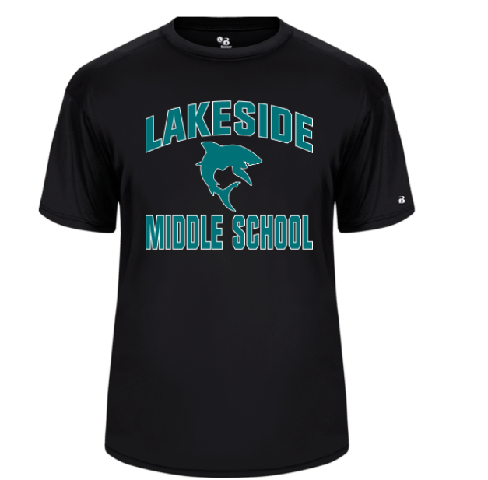
1 shirt: $17
2 shirts: $30
3 shirts: $45

Use the following QR Code to our PTO Spirit Wear webpage.

---------------------------------------------------------------------------------
Paper T-Shirt Order Form

Student Name: ____________________________________ Chomp Teacher:_________________

Grade (circle your grade): 6 7 8

T-shirt 1 (circle your choice): Youth M Youth L Youth XL Adult XS Adult S Adult M Adult L
Adult XL Adult XXL

T-shirt 2 (circle your choice): Youth M Youth L Youth XL Adult XS Adult S Adult M Adult L
Adult XL Adult XXL

T-shirt 3 (circle your choice): Youth M Youth L Youth XL Adult XS Adult S Adult M Adult L
Adult XL Adult XXL

Check the box for the number of shirts you’re buying:
__ 1 T-shirt $17
__ 2 T-shirts $30
__ 3 T-shirts $45

Please attach a check made out to Sutherland Middle School PTO (this is not a typo - we are in the process of changing our name to Lakeside Middle School PTO) and return to your Chomp Teacher or the School Office.

